Experiment 3:
Aim: Perform the function-oriented diagram: Data Flow Diagram.
DFD is the abbreviation for Data Flow Diagram. The flow of data of a system or a process is represented by DFD. It also gives insight into the inputs and outputs of each entity and the process itself. DFD does not have control flow and no loops or decision rules are present. Specific operations depending on the type of data can be explained by a flowchart. Data Flow Diagram can be represented in several ways. The DFD belongs to structured-analysis modeling tools. Data Flow diagrams are very popular because they help us to visualize the major steps and data involved in software-system processes.
Components of DFD
The Data Flow Diagram has 4 components:
- Process
Input to output transformation in a system takes place because of process function. The symbols of a process are rectangular with rounded corners, oval, rectangle or a circle. The process is named a short sentence, in one word or a phrase to express its essence
- Data Flow
Data flow describes the information transferring between different parts of the systems. The arrow symbol is the symbol of data flow. A relatable name should be given to the flow to determine the information which is being moved. Data flow also represents material along with information that is being moved. Material shifts are modeled in systems that are not merely informative. A given flow should only transfer a single type of information. The direction of flow is represented by the arrow which can also be bi-directional.
- Warehouse
The data is stored in the warehouse for later use. Two horizontal lines represent the symbol of the store. The warehouse is simply not restricted to being a data file rather it can be anything like a folder with documents, an optical disc, a filing cabinet. The data warehouse can be viewed independent of its implementation. When the data flow from the warehouse it is considered as data reading and when data flows to the warehouse it is called data entry or data updation.
- Terminator
The Terminator is an external entity that stands outside of the system and communicates with the system. It can be, for example, organizations like banks, groups of people like customers or different departments of the same organization, which is not a part of the model system and is an external entity. Modeled systems also communicate with terminator.
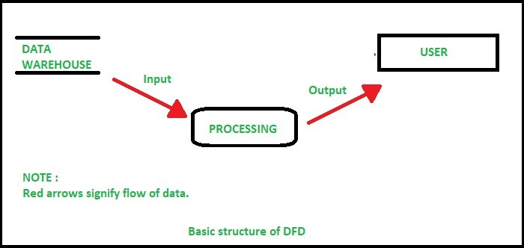
Rules for creating DFD
- The name of the entity should be easy and understandable without any extra assistance(like comments).
- The processes should be numbered or put in ordered list to be referred easily.
- The DFD should maintain consistency across all the DFD levels.
- A single DFD can have maximum processes upto 9 and minimum 3 processes.
Levels of DFD
DFD uses hierarchy to maintain transparency thus multilevel DFD’s can be created. Levels of DFD are as follows:
- 0-level DFD
- 1-level DFD: ● 2-level DFD:
Advantages of DFD
- It helps us to understand the functioning and the limits of a system.
- It is a graphical representation which is very easy to understand as it helps visualize contents.
- Data Flow Diagram represent detailed and well explained diagram of system components.
- It is used as the part of system documentation file.
- Data Flow Diagrams can be understood by both technical or nontechnical person because they are very easy to understand.
Disadvantages of DFD
- At times DFD can confuse the programmers regarding the system.
- Data Flow Diagram takes long time to be generated, and many times due to this reasons analysts are denied permission to work on it.
Result: Insert youre domain DFD diagram here

Viva Question :

Experiment 4:
Aim: To study about the Use Case Model and draw it.

Introduction
A use case is a methodology used in system analysis to identify, clarify and organize system requirements. The use case is made up of a set of possible sequences of interactions between systems and users in a particular environment and related to a particular goal. The method creates a document that describes all the steps taken by a user to complete an activity.

Use cases are typically written by business analysts and can be employed during several stages of software development, such as planning system requirements, validating design, testing software and creating an outline for online help and user manuals. A use case document can help the development team identify and understand where errors may occur during a transaction so they can resolve them.
Every use case contains three essential elements:

  - The actor. The system user -- this can be a single person or a group of people interacting with the process.
  - The goal. The final successful outcome completes the process.
  - The system. The process and steps taken to reach the end goal, including the necessary functional requirements and their anticipated behaviors.

Characteristics of use case
Use cases describe the functional requirements of a system from the end user's perspective, creating a goal-focused sequence of events that is easy for users and developers to follow. A complete use case will include one main or basic flow and various alternate flows. The alternate flow, also known as an extending use case, describes normal variations to the basic flow as well as unusual situations.

A use case should display the following characteristics:

  - Organizes functional requirements.
  - Models the goals of system/actor interactions.
  - Records paths -- called scenarios -- from trigger events to goals.
  - Describes one main flow of events and various alternate flows.
  - Multi-level, so that one use case can use the functionality of another one.

How to write a use case
There are two different types of use cases: business use cases and system use cases.

A business use case is a more abstract description that's written in a technology-agnostic way, referring only to the business process being described and the actors that are involved in the activity. A business use case identifies the sequence of actions that need to be performed by the business to provide a meaningful, observable result to the end user.

On the other hand, a system use case is written with more detail than a business use case, referring to the specific processes that must happen in various parts of the system to reach the final user goal. A system use case diagram will detail functional specifications, including dependencies, necessary internal supporting features and optional internal features.

When writing a use case, the design scope should be considered to identify all elements that lie within and outside the boundaries of the processes. Anything essential to the use case that lies outside its boundaries should be indicated with a supporting actor or by another use case. The design scope can be a specific system, a subsystem or the entire enterprise. Use cases that describe business processes are typically of the enterprise scope.

As mentioned, the three basic elements that make up a use case are actors, the system and the goal. Other additional elements to consider when writing a use case include:
  - Stakeholders, or anybody with an interest or investment in how the system performs.
  - Preconditions, or the elements that must be true before a use case can occur.
  - Triggers, or the events that cause the use case to begin.
  - Post-conditions, or what the system should have completed by the end of the steps.

The use case is written using narrative language, describing the functional requirements of a system from the end user's perspective. A use case diagram is created using a unified modeling language, with each step represented by its name in an oval; each actor represented by a stick figure with their name written below; each action indicated by a line between the actor and step; and the system boundaries indicated by a rectangle around the use case.

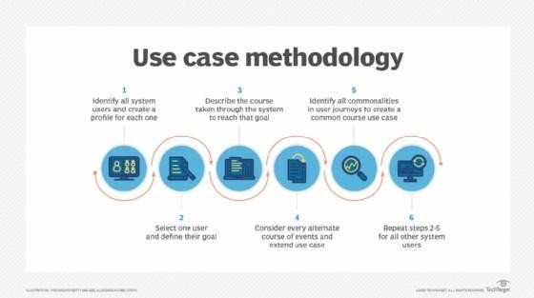

The writing process includes:

- Identifying all system users and creating a profile for each one. This includes every role played by a user who interacts with the system.
- Selecting one user and defining their goal -- or what the user hopes to accomplish by interacting with the system. Each of these goals becomes a use case.
- Describing the course taken for each use case through the system to reach that goal.
- Considering every alternate course of events and extending use cases -- or the different courses that can be taken to reach the goal.
- Identifying commonalities in journeys to create common course use cases and write descriptions of each.
- Repeating steps two through five for all other system users.

When writing a use case, developers may use a sequence diagram -- which shows how objects react along a timeline -- to model the interactions between objects in a single use case. Sequence diagrams allow developers to see how each part of the system interacts with others to perform a specific function as well as the order in which these interactions occur to complete a use case.

Benefits of use case
A single use case can benefit developers by revealing how a system should behave while also helping identify any errors that could arise in the process.

Other benefits of use case development include:

  - The list of goals created in the use case writing process can be used to establish the complexity and cost of the system.
  - By focusing both on the user and the system, real system needs can be identified earlier in the design process.
  - Since use cases are written primarily in a narrative language they are easily understood by stakeholders, including customers, users and executives -- not just by developers and testers.
  - The creation of extending use cases and the identification of exceptions to successful use case scenarios saves developers time by making it easier to define subtle system requirements.
  - By identifying system boundaries in the design scope of the use case, developers can avoid scope creep.
  - Premature design can be avoided by focusing on what the system should do rather than how it should do it.

In addition, use cases can be easily transformed into test cases by mapping the common course and alternate courses and gathering test data for each of the scenarios. These functional test cases will help the development team ensure all functional requirements of the system are included in the test plan.

Furthermore, use cases can be used in various other areas of software development, including project planning, user documentation and test case definitions. Use cases can also be used as a planning tool for iterative development.

Result: Insert youre domain USE CASE diagram here

VIVA VOICE QUESTIONS:
Q: What is use case diagram?
Q: What is an actor?
Q: What is use case?

Q: What are the contents of use case diagram?
Q: What is the use case name prefixed by the name of the package in which that use case lives?
Q: How can you model the content of a system?
Q: Name the three types of relationships in a use case diagram?

Experiment 5:
Aim: To perform structural view analysis of class and object diagram.
Class diagram is a static diagram. It represents the static view of an application. Class diagram is not only used for visualizing, describing, and documenting different aspects of a system but also for constructing executable code of the software application.
Class diagram describes the attributes and operations of a class and also the constraints imposed on the system. The class diagrams are widely used in the modeling of object- oriented systems because they are the only UML diagrams, which can be mapped directly with object-oriented languages.
Class diagram shows a collection of classes, interfaces, associations, collaborations, and constraints. It is also known as a structural diagram.
Purpose of Class Diagrams
The purpose of class diagram is to model the static view of an application. Class diagrams are the only diagrams which can be directly mapped with object-oriented languages and thus widely used at the time of construction.
UML diagrams like activity diagram, sequence diagram can only give the sequence flow of the application, however class diagram is a bit different. It is the most popular UML diagram in the coder community.
The purpose of the class diagram can be summarized as −
- Analysis and design of the static view of an application.
- Describe responsibilities of a system.
- Base for component and deployment diagrams.
- Forward and reverse engineering.

Vital components of a Class Diagram

The class diagram is made up of three sections:

- Upper Section: The upper section encompasses the name of the class. A class isa representation of similar objects that shares the same relationships, attributes, operations, and semantics. Some of the following rules that should be taken into account while representing a class are given below:

  - Capitalize the initial letter of the class name.
  - Place the class name in the center of the upper section.
  - A class name must be written in bold format.
  - The name of the abstract class should be written in italics format.
- Middle Section: The middle section constitutes the attributes, which describe the quality of the class. The attributes have the following characteristics:

- The attributes are written along with its visibility factors, which are public (+), private (-), protected (#), and package (~).
- The accessibility of an attribute class is illustrated by the visibility factors.
- A meaningful name should be assigned to the attribute, which will explain its usage inside the class.
- Lower Section: The lower section contain methods or operations. The methods are represented in the form of a list, where each method is written in a single line. It demonstrates how a class interacts with data.
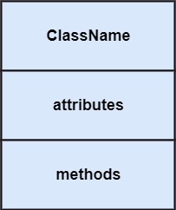

Relationships

In UML, relationships are of three types:

- Dependency: A dependency is a semantic relationship between two or more classes where a change in one class cause changes in another class. It forms a weaker relationship.
In the following example, Student_Name is dependent on the Student_Id.
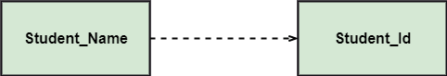
- Generalization: A generalization is a relationship between a parent class (superclass) and a child class (subclass). In this, the child class is inherited from the parent class. For example, The Current Account, Saving Account, and Credit Account are the generalized form of Bank Account.

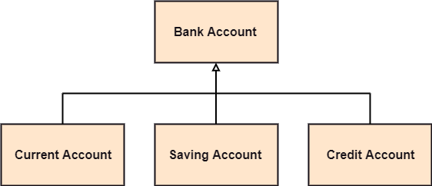
- Association: It describes a static or physical connection between two or more objects.
It depicts how many objects are there in the relationship. For example, a department is associated with the college.
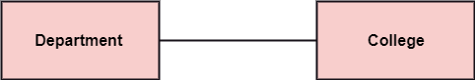

Multiplicity: It defines a specific range of allowable instances of attributes. In case if a range is not specified, one is considered as a default multiplicity.

For example, multiple patients are admitted to one hospital.
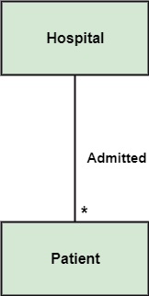

Aggregation: An aggregation is a subset of association, which represents has a relationship. It is more specific then association. It defines a part-whole or part-of relationship. In this kind of relationship, the child class can exist independently of its parent class.

The company encompasses a number of employees, and even if one employee resigns, the company still exists.
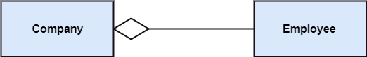

Composition: The composition is a subset of aggregation. It portrays the dependency between the parent and its child, which means if one part is deleted, then the other part also gets discarded. It represents a whole-part relationship.

A contact book consists of multiple contacts, and if you delete the contact book, all the contacts will be lost.
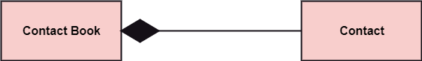

Abstract Classes

In the abstract class, no objects can be a direct entity of the abstract class. The abstract class can neither be declared nor be instantiated. It is used to find the functionalities across the classes. The notation of the abstract class is similar to that of class; the only difference is that the name of the class is written in italics. Since it does not involve any implementation for a given function, it is best to use the abstract class with multiple objects.

Let us assume that we have an abstract class named displacement with a method declared inside it, and that method will be called as a drive (). Now, this abstract class method can be implemented by any object, for example, car, bike, scooter, cycle, etc.
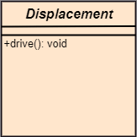

An Object Diagram can be referred to as a screenshot of the instances in a system and the relationship that exists between them. Since object diagrams depict behaviour when objects have been instantiated, we are able to study the behavior of the system at a particular instant. Object diagrams are vital to portray and understand functional requirements of a system.
In other words, “An object diagram in the Unified Modeling Language (UML), is a diagram that shows a complete or partial view of the structure of a modeled system at a specific time.”

Difference between an Object and a Class Diagram –
An object diagram is similar to a class diagram except it shows the instances of classes in the system. We depict actual classifiers and their relationships making the use of class diagrams. On the other hand, an Object Diagram represents specific instances of classes and relationships between them at a point of time.

What is a classifier?
In UML a classifier refers to a group of elements that have some common features like methods, attributes and operations. A classifier can be thought of as an abstract metaclass which draws a boundary for a group of instances having common static and dynamic features. For example, we refer a class, an object, a component, or a deployment node as classifiers in UML since they define a common set of properties.
An Object Diagram is a structural diagram which uses notation similar to that of class diagrams. We are able to design object diagrams by instantiating classifiers.

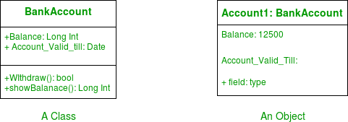
Object Diagrams use real world examples to depict the nature and structure of the system at a particular point in time. Since we are able to use data available within objects, Object diagrams provide a clearer view of the relationships that exist between objects.
Figure – a class and its corresponding object Notations Used in Object Diagrams –
- Objects or Instance specifications – When we instantiate a classifier in a system, the object we create represents an entity which exists in the system. We can represent the changes in object over time by creating multiple instance specifications. We use a rectangle to represent an object in an Object Diagram. An object is generally linked to other objects in an object diagram.

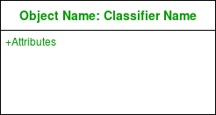
Figure – notation for an Object
For example – In the figure below, two objects of class Student are linked to an object of class College.
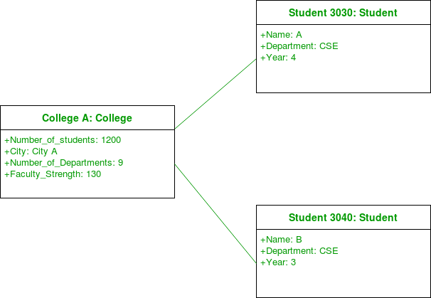
Figure – an object diagram using a link and 3 objects
Notation Meaning
0..1 Zero or one

1 One only

0..* Zero or more

* Zero or more

1..* One or more

7 Seven only

0..2 Zero or two

4..7 Four to seven

- Links – We use a link to represent a relationship between two objects.
Figure – notation for a link
We represent the number of participants on the link for each end of the link. We use the term association for a relationship between two classifiers. The term link is used to specify a relationship between two instance specifications or objects. We use a solid line to represent a link between two objects.
- Dependency Relationships – We use a dependency relationship to show when one element depends on another element.
Figure – notation for dependency relationship

Class diagrams, component diagrams, deployment and object diagrams use dependency relationships. A dependency is used to depict the relationship between dependent and independent entities in the system. Any change in the definition or structure of one element may cause changes to the other. This is a unidirectional kind of relationship between two objects.
Dependency relationships are of various types specified with keywords (sometimes within angular brackets”).
Abstraction, Binding, Realization, Substitution and Usage are the types of dependency relationships used in UML.
For example – In the figure below, an object of Player class is dependent (or uses) an object of Bat class.

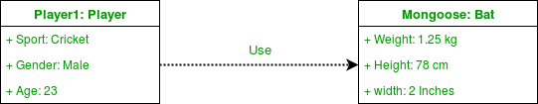
Figure – an object diagram using a dependency relationship
- Association – Association is a reference relationship between two objects (or classes).
Figure – notation for association
Whenever an object uses another it is called an association. We use association when one object references members of the other object. Association can be uni-directional or bi-directional. We use an arrow to represent association.
For example – The object of Order class is associated with an object of Customer class.
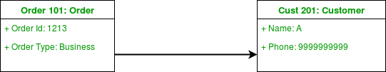
Figure – an object diagram using association
- Aggregation – Aggregation represents a “has a” relationship.
Figure – notation for aggregation
Aggregation is a specific form of association. On relationship; aggregation is more specific than ordinary association. It is an association that represents a part-whole or part-of relationship. It is a kind of parent -child relationship however it isn’t inheritance. Aggregation occurs when the lifecycle of the contained objects does not strongly depend on the lifecycle of container objects.

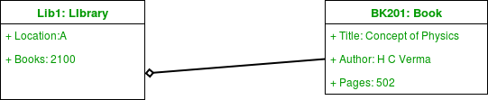
Figure – an object diagram using aggregation
For example – A library has an aggregation relationship with books. Library has books or books are a part of library. The existence of books is independent of the existence of the library. While implementing, there isn’t a lot of difference between aggregation and association. We use a hollow diamond on the containing object with a line which joins it to the contained object.
- Composition – Composition is a type of association where the child cannot exist independent of the other.
Figure – notation for composition

Composition is also a special type of association. It is also a kind of parent child relationship but it is not inheritance. Consider the example of a boy Gurkaran: Gurkaran is composed of legs and arms. Here Gurkaran has a composition relationship with his legs and arms. Here legs and arms cant exist without the existence of their parent object. So whenever independent existence of the child is not possible we use a composition relationship. We use a filled diamond on the containing object with a line which joins it to the contained object.
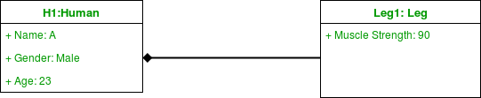
Figure – an object diagram using composition
For Example – In the figure below, consider the object Bank1. Here an account cannot exist without the existence of a bank.
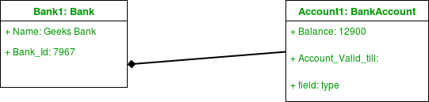
Figure – a bank is composed of accounts

Difference between Association and Dependency –

Association and dependency are often confused in their usage. A source of confusion was the use of transient links in UML 1. Meta-models are now handled differently in UML 2 and the issue has been resolved.
There are a large number of dependencies in a system. We only represent the ones which are essential to convey for understanding the system. We need to understand that every association implies a dependency itself. We , however, prefer not to draw it separately. An association implies a dependency similar to a way in which generalization does.

How to draw an Object Diagram?

- Draw all the necessary class diagrams for the system.
- Identify the crucial points in time where a system snapshot is needed.
- Identify the objects which cover crucial functionality of the system.
- Identify the relationship between objects drawn.

Uses of an Object Diagram –

  - Model the static design(similar to class diagrams ) or structure of a system using prototypical instances and real data.
  - Helps us to understand the functionalities that the system should deliver to the users.
  - Understand relationships between objects.
  - Visualise, document, construct and design a static frame showing instances of objects and their relationships in the dynamic story of life of a system.
  - Verify the class diagrams for completeness and accuracy by using Object Diagrams as specific test cases.
  - Discover facts and dependencies between specific instances and depicting specific examples of classifiers.

Class Diagram of Cab Booking System:

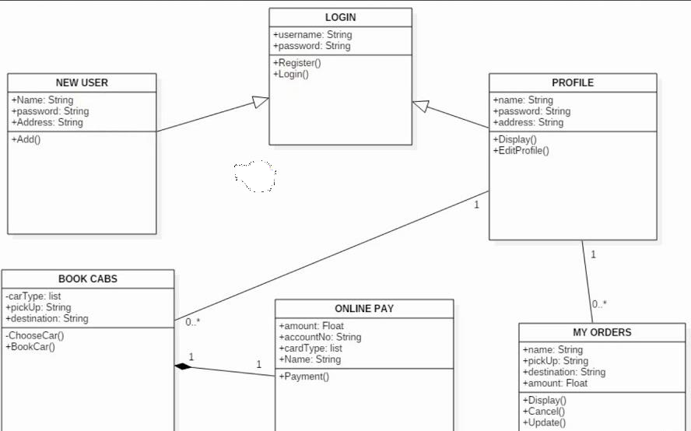

Object Diagram of Cab Booking System:

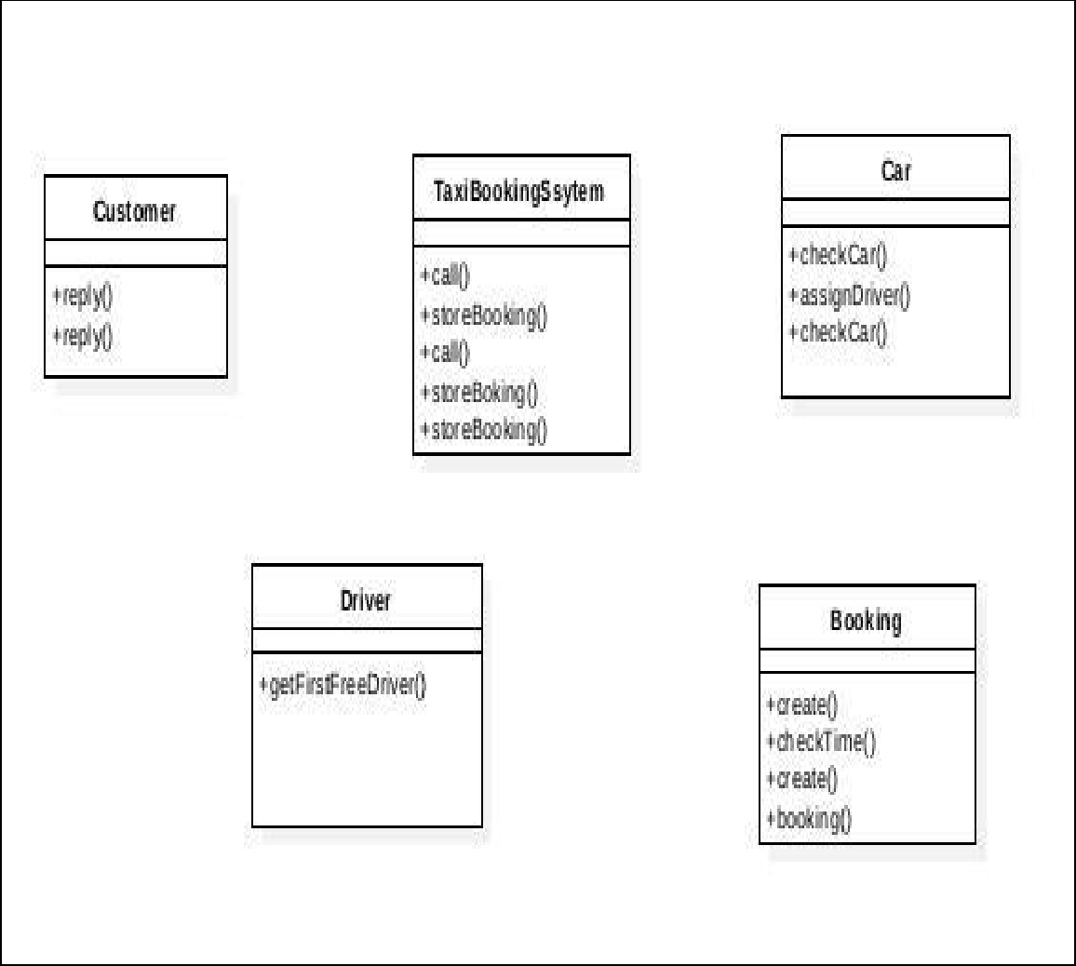

VIVA VOICE QUESTIONS:
Q: What is the need of an Object diagram?
Q: Write some applications of object model?
Q: Names the diagrams of Booch Methodology?
Q: What is mean by object?
Q: Write the characteristics of an object.

Q: What is unified modeling language?

Experiment 6:
Aim : Sequence diagram and collaboration diagram

Theory: UML sequence diagrams model the flow of logic within the system in a visual manner, enabling the user both to document and validate the logic, and are commonly used for both analysis and design purposes. Sequence diagrams are the most popular UML artifact for dynamic modeling, which focuses on identifying the behavior within your system. Sequence diagrams, along with class diagrams and physical data models are the most important design-level models for modern application development.

Sequence diagrams are typically used to model:
1. Usage scenarios. A usage scenario is a description of a potential way the system is used. The logic of a usage scenario may be part of a use case, perhaps an alternate course. It may also be one entire pass through a use case, such as the logic described by the basic course of action or a portion of the basic course of action, plus one or more alternate scenarios. The logic of a usage scenario may also be a pass through the logic contained in several use cases. For example, a student enrolls in the university, and then immediately enrolls in three seminars.
2. The logic of methods. Sequence diagrams can be used to explore the logic of a complex operation, function, or procedure. One way to think of sequence diagrams, particularly highly detailed diagrams, is as visual object code.
3. The logic of services. A service is effectively a high-level method, often one that can be invoked by a wide variety of clients. This includes web-services as well as business transactions implemented by a variety of technologies such as CICS/COBOL or CORBA-compliant object request brokers (ORBs).

FIG .shows the logic for how to enroll in a seminar. One should often develop a system-level sequence diagram to help both visualize and validate the logic of a usage scenario. It also helps to identify significant methods/services, such as checking to see if the applicant already exists as a student, which the system must support.

Figure 3. Enrolling in a seminar (method).
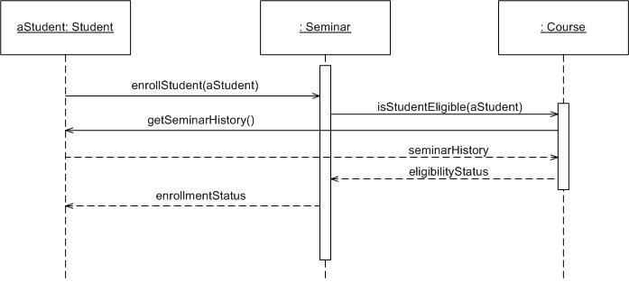

The dashed lines hanging from the boxes are called object lifelines, representing the life span of the object during the scenario being modeled. The long, thin boxes on the lifelines are activation boxes, also called method-invocation boxes, which indicate processing is being performed by the target object/class to fulfill a message.

How to Draw Sequence Diagrams
Sequence diagramming really is visual coding, even when you are modeling a usage scenario via a system-level sequence diagram.
While creating a sequence diagram ,start by identifying the scope of what you are trying to model.You should typically tackle small usage scenarios at the system level or a single method/service at the detailed object level.
You should then work through the logic with at least one more person, laying out classifiers across the top as you need them. . The heart of the diagram is in the messages, which you add to the diagram one at a time as you work through the logic. You should rarely indicate return values, instead you should give messages intelligent names which often make it clear what is being returned.
Notations of sequence diagram : Include all notations of sequence diagram
collaboration Diagram
THEORY
Collaboration diagrams are also relatively easy to draw. They show the relationship between objects and the order of messages passed between them. The objects are listed as icons and arrows indicate the messages being passed between them. The numbers next to the messages are called sequence numbers. As the name suggests, they show the sequence of the messages as they are passed between the objects. There are many acceptable sequence numbering schemes in UML. A simple 1, 2, 3... format can be used, as the example below shows, or for more detailed and complex diagrams a 1, 1.1 ,1.2, 1.2.1... scheme can be used.
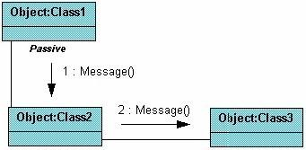

The example below shows a simple collaboration diagram for the placing an order use case. This time the names of the objects appear after the colon, such as :Order Entry Window following the objectName:className naming convention. This time the class name is shown to demonstrate that all of objects of that class will behave the same way.
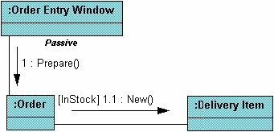
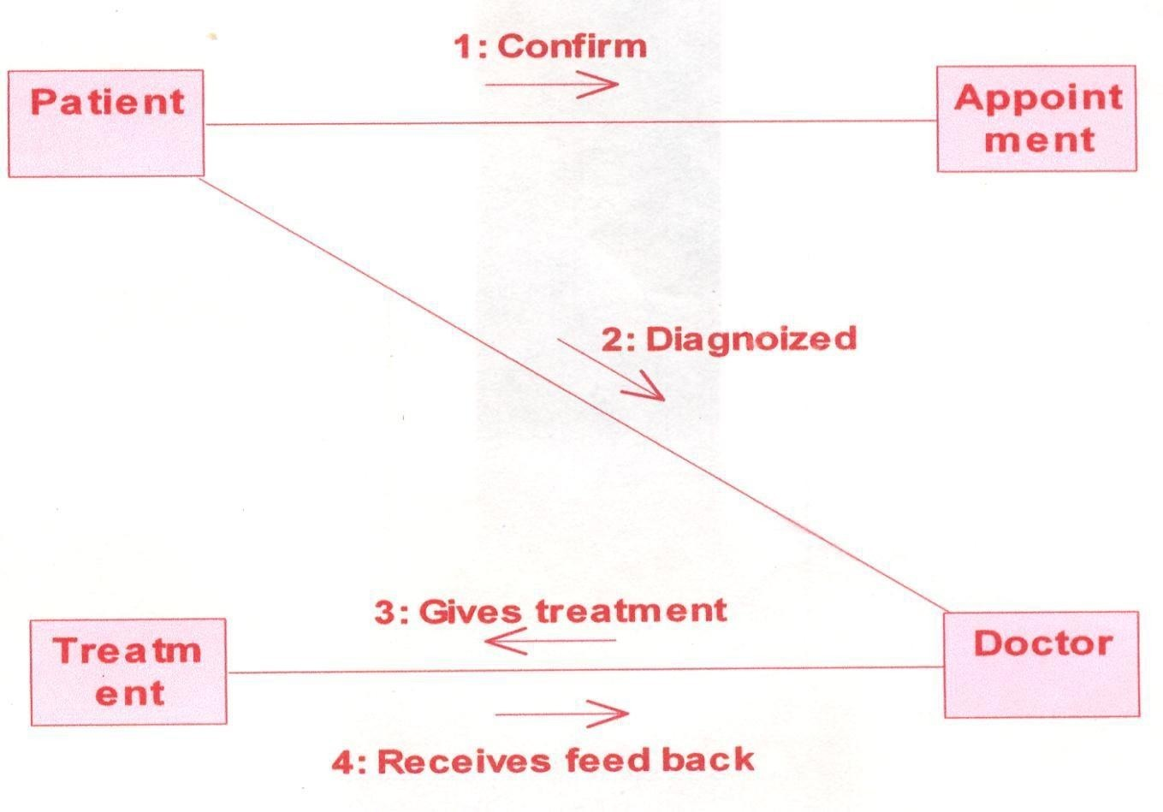
Result : insert collaboration Diagram sequence diagram
VIVA VOICE QUESTIONS:
Q: What are the contents of collaboration
Q: What is the purpose of collaboration diagram? :
Q: What is component?

Q: What is deployment?

Experiment 7:
Aim: To perform State-chart diagram , Activity Diagram
THEORY
UML 2 activity diagrams are typically used for business process modeling, for modeling the logic captured by a single use case or usage scenario, or for modeling the detailed logic of a business rule. Although UML activity diagrams could potentially model the internal logic of a complex operation it would be far better to simply rewrite the operation so that it is simple enough that you don‘t require an activity diagram. In many ways UML activity diagrams are the object-oriented equivalent of flow charts and data flow diagrams (DFDs) from structured development.
Let‘s start by describing the basic notation :
- Initial node. The filled in circle is the starting point of the diagram. An initial node isn‘t required although it does make it significantly easier to read the diagram.
- Activity final node. The filled circle with a border is the ending point. An activity diagram can have zero or more activity final nodes.
- Activity. The rounded rectangles represent activities that occur. An activity may be physical, such as Inspect Forms, or electronic, such as Display Create Student Screen.
- Flow/edge. The arrows on the diagram. Although there is a subtle difference between flows and edges,never a practical purpose for the difference although.
- Fork. A black bar with one flow going into it and several leaving it. This denotes the beginning of parallel activity.
- Join. A black bar with several flows entering it and one leaving it. All flows going into the join must reach it before processing may continue. This denotes the end of parallel processing.
- Condition. Text such as [Incorrect Form] on a flow, defining a guard which must evaluate to true in order to traverse the node.
- Decision. A diamond with one flow entering and several leaving. The flows leaving include conditions although some modelers will not indicate the conditions if it is obvious.
- Merge. A diamond with several flows entering and one leaving. The implication is that one or more incoming flows must reach this point until processing continues, based on any guards on the outgoing flow.
- Partition. If figure is organized into three partitions, it is also called swimlanes, indicating who/what is performing the activities (either the Applicant, Registrar, or System).
- Sub-activity indicator. The rake in the bottom corner of an activity, such as in the Apply to University activity, indicates that the activity is described by a more finely detailed activity diagram.
- Flow final. The circle with the X through it. This indicates that the process stops at this point.

GUIDELINES ASSOCIATED FOR DRAWING AN ACTIVITY DIAGRAM

1.General Guidelines
2.Activities
3.Decision Points
4.Guards
5.Parallel Activities
6.Swimlane Guidelines
7.Action-Object Guidelines

1. General Guidelines
Figure1. Modeling a business process with a UML Activity Diagram.
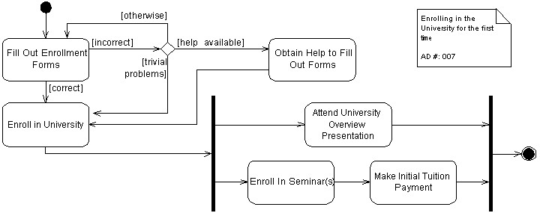

- Place The Start Point In The Top-Left Corner. A start point is modeled with a filled in circle, using the same notation that UML State Chart diagrams use. Every UML Activity Diagram should have a starting point, and placing it in the top-left corner reflects the way that people in Western cultures begin reading. Figure1, which models the business process of enrolling in a university, takes this approach.
- Always Include an Ending Point. An ending point is modeled with a filled in circle with a border around it, using the same notation that UML State Chart diagrams use. Figure1 is interesting because it does not include an end point because it describes a continuous process – sometimes the guidelines don‘t apply.
- Flowcharting Operations Implies the Need to Simplify. A good rule of thumb is that if an operation is so complex you need to develop a UML Activity diagram to understand it that you should consider refactoring it.
Prepare STATE CHART DIAGRAM
THEORY:
  - State Chart Diagrams provide a way to model the various states in which an object can exist.
  - There are two special states: the start state and the stop state.
The Start state is represented by a block dot.
The Stop state is represented by a bull’s eye.
  - A condition enclosed in square brackets is called a guard condition, and controls when a transition can or cannot occur.
  - Process that occur while an object is in certain state are called actions.

STEPS TO DRAW STATE CHART DIAGRAM IN RATIONAL ROSE SOFTWARE

- To insert new state diagram secondary click on Logical View.
    - Select---New----State chart Diagram.
    - A new diagram will be created, type in a name for the new diagram.

- Now double click on the new diagram to open it on the stage.
  - To begin the diagram click on the “START STATE” button.
  - Place a start state icon on the diagram by clicking the mouse once.

- Now add states to the diagram, these make up the content of the diagram. Click on the state button. Place the instances for each state into the diagram and type in names for them.

- Now arrange the states to fill the diagram better. Drag the states to new positions to make the easiest layout to work with.

- Add an end state to the diagram by clicking the “END STATE” button. Place an instance into the diagram. Now add relationships to the diagram.

- Click on the “STATE TRANSITION” button and drag arrows between the appropriate states.

- To edit the specification secondary click on the relation lines and select “OPEN SPECIFICATION” button. Add a name for the event in the specification. Then click on
―apply‖ and then on ―OK‖ button.
- Add details to the specifications of the other relationships in the same way.

- There may be instances on the diagram where a state can join more than one state. In this case add a relationship in the same way. Then enter the specification for the new state.
Result: Include Activity and State Chart Diagram here.
Conclusion:
VIVA VOICE QUESTIONS:
Q: What is Association?
Q: How Association is rendered?
Q: What is binary association?
Q: What is n-ary association?
Q: What are the four adornments that apply to association?
Q: What is an activity?.
Q: What is control flow, work flow patterns?
Q: What is a sub activity state?
Q: Name the two properties of a part of relationship.

Experiment 8:

7. Name of the experiment: Component diagram for ATM System
Aim: To design and implement Component diagram for ATM System

Theory
Component diagrams are used to model physical aspects of a system. Physical aspects are the elements like executable, libraries, files, documents etc. which resides in a node. So component diagrams are used to visualize the organization and relationships among components in a system.These diagrams are also used to make executable systems.
Purpose:
- Component diagrams can be described as a static implementation view of a system.
- Static implementation represents the organization of the components at a particular moment.
- A singlecomponent diagram cannot represent the entire system but a collection of diagrams are used torepresent the whole.
Before drawing a component diagram the following artifacts are to be identified clearly:
- Files used in the system.
- Libraries and other artifacts relevant to the application. • Relationships among the artifacts.
Now after identifying the artifacts the following points needs to be followed:
- Use a meaningful name to identify the component for which the diagram is to be drawn.
- Prepare a mental layout before producing using tools. • Use notes for clarifying important points.

Contents
- Components,
- Interfaces,
- Relationships

Procedure:-
- First user component is created.
- ATM system package is created.
- In it various components such as withdraw money, deposit money, check balance, transfermoney etc. are created.
- Association relationship is established between user and other components.
Diagram
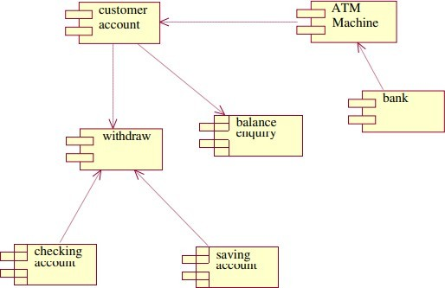
Insert your domain component diagram
VIVA VOICE QUESTIONS:
Q: What is Dependency?
Q: How the dependency is rendered?
on Q: Define Object Oriented Analysis?
Q: Write the two types of Implementation diagram?
Q: What is the Generalization?
Q: Write the guidelines for preparing the Documentation.

Experiment 9:

Name of the experiment: Deployment diagram for ATM System
Aim: To design and implement Deployment diagram for ATM System

Theory
Deployment diagrams are used for describing the hardware components where software components are deployed. Component diagrams and deployment diagrams are closely related. Component diagrams are used to describe the components and deployment diagrams shows how they are deployed in hardware.
Purpose:
- Deployment diagrams are used to visualize the topology of the physical components of a system where the software components are deployed.
- So deployment diagrams are used to describe the staticdeployment view of a system.

Contents:-
- Nodes
- Dependency & Association relationships

Procedure:-
- First user node is created
- Various nodes withdraw money, deposit money, and check balance, transfer money etc. are created
- Association relationship is established between user and other nodes.
- Dependency is established between deposit money and check balance.
DIAGRAM for Hospital
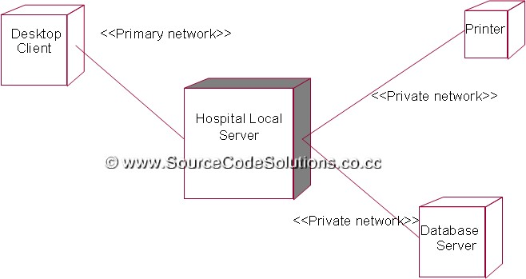
DIAGRAM for ATM Machine
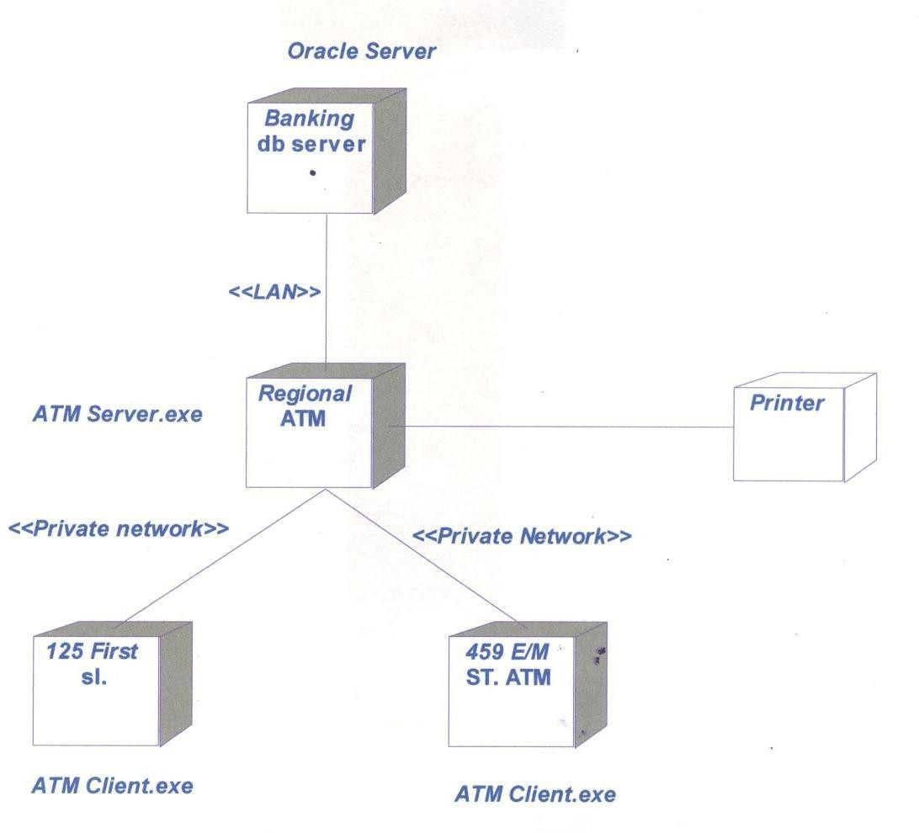
VIVA VOICE QUESTIONS:
Q: What are the parts of a deployment diagram?
Q: What is a note?
Q: What is Association?
Q: How the note is rendered?
Q: What are the four adornments that apply to association?
Q: What is stereotype?

Q: What is a Role?
Q: How we can describe nature of relationship in association?

